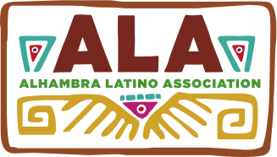

Student Food/Arts/Crafts Vendor
Agreement

Cultural Festival
Dia De Los Muertos - Celebration of Life

SPACE RESERVATION DEADLINE: October 25, 2015

Student Club Food/Arts/Crafts Vendor agrees to pay $20 for vendor space that includes two tables and two folding chairs with an option to bring your own tarp/canopy, and a 20-foot extension cord if necessary. Student Club Vendors will be allowed into festival free of charge.

There is parking at the South end of the school campus. Student volunteers will be available for loading/unloading items. Please note that entry into school campus is through the South gate of school parking lot where student vendors will check in and receive a wristband.

For further assistance or questions, contact ALA Board Correspondence Secretary, Gina Grageda at (626) 230-1049, Email: ginagrageda@gmail.com

If need to cancel, please notify Gina Grageda as soon as possible. If canceling 48 hours or less before Festival, the $20 fee is forfeit.
Please visit our website at: www.alhambralatinoassociation.com

Date: Saturday, November 7, 2015

Place: San Gabriel High School
801 S. Ramona St.
San Gabriel, CA 91776

Time: 9:00 a.m. Set-up Festival opens to public at 11:00 a.m. and ends at 3:00 p.m.
- - - - - - - - - - - - - - - - - - - - - - - - - - - - - - - - - - - - - - - - - - - -- - - - - - - - - - - - - - - - - - - - - -- - - - - - - -
Checks payable to: Alhambra Latino Association Mail to: P.O. Box 6062, Alhambra, CA 91801

Name of Vendor: Food/Arts/Craft Items for Sale:

School Site: Advisor:

Phone: E-mail:

