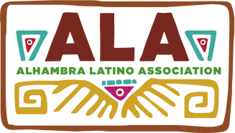

Food Vendor Agreement

Cultural Festival

Dia De Los Muertos - Celebration of Life

SPACE RESERVATION DEADLINE: October 25, 2015

Vendor agrees to pay $60 for vendor space that includes two tables and two folding chairs with an option to bring your own tarp/canopy, and a 20-foot extension cord if necessary. Vendor and one assistant will be allowed into festival free of charge. A Food Vendors’ Permit is required.

There is parking at the South end of the school campus. Student volunteers will be available for loading/unloading items. Please note that entry into school campus is through the South gate parking lot of school where vendor and one assistant will check in and receive a wristband.

For further assistance or questions, contact ALA Board Correspondence Secretary, Gina Grageda at (626) 230-1049; Email: ginagrageda@gmail.com

If need to cancel, please notify Gina Grageda as soon as possible. If canceling 48 hours or less before Festival, a $20 fee is forfeit. Balance of deposit will be returned within four weeks.
Please visit our website at: www.alhambralatinoassociation.com

Date: Saturday, November 7, 2015

Place: San Gabriel High School
801 S. Ramona St.
San Gabriel, CA 91776

Time: 9:00 a.m. Set-up Festival opens to public at 11:00 a.m. and ends at 3:00 p.m.
- - - - - - - - - - - - - - - - - - - - - - - - - - - - - - - - - - - - - - - - - - - -- - - - - - - - - - - - - - - - - - - - - -- - - - - - - -
Checks payable to: Alhambra Latino Association Mail to: P.O. Box 6062, Alhambra, CA 91801

Name of Vendor: Food Item/s for Sale:

Address:

Phone: E-mail:

