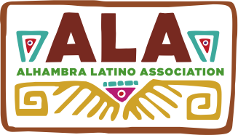

Date: Fall 2015

To: Alhambra Unified School District Students
1st Through 8th Grade Elementary
9th through 12th Grade High School

From Alhambra Latino Association
Gina Grageda, ALA Board Correspondence Secretary
626.230.1049

Re: ALA Cultural Festival Saturday, November 7, 2015
Art Contest and Exhibit
Dia De Los Muertos – Celebration of Life

Alhambra Latino Association invites AUSD students to participate in our annual Art Contest. The ALA Cultural Festival will take place at San Gabriel High School on Saturday, November 7, 2015. This contest will give students almost eight weeks to work on original projects. Artworks can be submitted beginning today, and up to the deadline of 12:00 noon, Thursday, October 29, 2015. Please bring or mail artworks to the Visual and Performing Arts office located at Baldwin Elementary, 900 S. Almansor St., Alhambra, CA 91801. Enter VAPA Office from Los Higos Street.

Attached is the Entry Form and Guidelines. All art entries will be exhibited at the Cultural Festival where Certificates and Honorable Mentions will be awarded.

We look forward to a multitude of entries from our many talented and creative students.

Good Luck to all!

