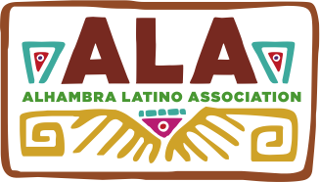
2015 GUIDELINES

Alhambra Latino Association Cultural Festival
Dia De Los Muertos – Celebration of Life
Art Contest and Exhibit – November 7, 2015

The Art Contest is open to all Alhambra Unified School District Elementary and High School students. Each student must be an AUSD student. Each entry must be an original in design and execution. This is your opportunity to create your own, interesting, distinctive, fresh, personal interpretation of:
Dia De Los Muertos – Celebration of Life Deadline: Noon - Thursday, October 29, 2015.

In order for the artworks to be displayed at the Festival, please follow instructions/restrictions:

Two-dimensional artwork: No heavy frames, No glass
Suggested Artwork categories as follows:

- Paintings: oil, acrylics, watercolor
- Drawings: pastels, colored pencil, pencil, charcoal, ink, markers
- Collage: paint, paper, fabric, etc.
- Prints: lithographs, silkscreen, block prints
- Mixed Media: Use of two or more mediums – pencil, watercolor, ink, etc.
- Computer Generated Art
- Photography

Three-dimension artwork: It must be transportable.
Not too heavy or large that it would be difficult to be moved.
Suggested Artwork categories as follows:

- Sculpture: ceramic, paper, plaster, wood, bas-relief
- Jewelry

Judging Criteria:

- Creativity/Originality
- Presentation/Execution
- Fulfills Theme: Dia De Los Muertos – Celebration of Life
- Impact of Concept or Impression/Visual Content

1st, 2nd and 3rd place winners will be awarded separately to Elementary School and High School student levels with a gift certificate (provider and amount to be announced). Honorable Mentions will be recognized.

For questions, please contact Gina Grageda, ALA Board Member - 626.230.1049.

Please Note: The Art Contest Entry Form is asking if a student wishes to donate their original artwork. Selected donated artwork will be framed and auctioned at the next Alhambra Latino Association Fund Raising Dinner on May 13, 2016.

