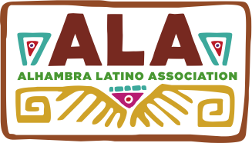
2015 ENTRY FORM

Alhambra Latino Association Cultural Festival
Dia De Los Muertos – Celebration of Life
Art Contest and Exhibit – N0vember 7, 2015

Elementary Grades 1 through 8 and All Grades High School Students

Deadline for entries is: 12:00 Noon, Thursday, October 29, 2015

Please print clearly and attach to back of entry

Student Name: Parent Signature:

Address:

Phone: E-mail

School: Grade level: Age:

Teacher’s Name (1st to 8th Gr.) Home Room #(HS):

Yes, I wish to donate my Please verify art entry is Original work by
Artwork to ALA. student whose name is on this application.

Check box to Donate Check box to Verify

Title of Work

Explanation of Work & Medium Used:

Mail or hand-carry all entries to:

Martha Baldwin School - Visual and Performing Arts Office
900 S. Almansor St. Alhambra, CA 91801 (Enter from Los Higos)
Attn: Gina Grageda Alhambra Latino Association Board Member – 626.230.1049 - Mobile

